HRIS Architecture Definition Document
Reporting Warehouse
Phil Crick

Contents
Document Control 3
Context 4
Intent 4
Background 4
Overview 4
Functional Overview 5
Functional Requirements 5
Non-Functional Requirements 6
Constraints 8
Principles 9
Solution Architecture 10
Container Diagram 10
Component Diagram 11
External Interfaces 0
Data View 3
Conceptual Data Models 3
T1 Model 3
Data Warehouse Backend Model 4
Data Warehouse Frontend Model 5
Data Volume 6
Backup and Retention 6
Infrastructure View 7
Production Infrastructure 8
Deployment View 9
Production 10
Deployment Process 11
Operational & Support View 12
Monitoring and Management 12
Log file locations 13
Processes 14
Shutdown 14
Startup 14
Take offline 14
Make online 15
Backup data 15
Restore data 15
Decision Log 0
Annex A – Warehouse Sizing 2

Document Control
Change Description | Author | Date | Version
First draft | Phil Crick | 26/08/16 | 1.0 Draft A
Feedback and data model changes | Phil Crick | 01/09/16 | 1.0 Draft B

Context

Intent
This document provides the overall architecture for the HRIS Reporting Warehouse. It describes the architecture from a number of viewpoints so that different audiences can get the information they need quickly and efficiently.

Background
Phase 1 of the HRIS project has significant reporting requirements to address before it can go live. A total of 94 high priority reports have been identified as needed by the business, many of which are not present in the out of the box functionality with the TechnologyOne product. Analysis has identified six different reporting tools in use in existing Anglicare-SA systems with only one set of tools able to satisfy project requirements fully. The ADD (Architecture Definition Document – this document) expands on the Solution Outline document to provide a complete architecture to build the recommended solution.

Overview
The main purpose of the Reporting Warehouse is to provide AnglicareSA with a centralised reporting capability for the HRIS project, but with scope to add in other reporting areas over time. It provides the following:
- Data Warehouse
- ETL tools
- Reporting tools
Intended audiences for this system are the People & Culture, Payroll, Finance and Service Delivery departments. The main architectural aspect of this system is a data warehouse:
Figure 1 Reporting Data Warehouse Context Diagram

Functional Overview
At a high level, the Reporting Warehouse has the following functions:
Figure 2 Functional Use Cases

Functional Requirements
ID | Description
1.092 | Screen based enquiry and export functionality
1.093 | Ability to create adhoc report outputs using an intuitive, user friendly interface allowing users to create, save and share their own reports
1.094 | Ability for users to replicate and manipulate standard reports to their own requirements
1.095 | Intuitive query tool using a pre-defined data set with drag and drop features for adhoc data interrogation
1.096 | Configurable run times reports such as –  - scheduled to run overnight  - scheduled to run on a particular day at a particular time
1.097 | Configuration of scheduled reports to be delivered to a specific destination such as –  - a user’s email inbox  - a web page  - a user logged into the application
1.098 | Ability to run reports as a background / server based task
1.199 | Ability to output reports to formats such as .xlsx, .xls, .csv. rtf, .pdf, .txt
1.100 | Ability to apply multiple graphical formats on reports such as bar graphs, pie charts
1.101 | Ability to drill down through reports to the transaction data
1.102 | The system must have the ability for managers to run reports through self service capability such as list of employees within their organisational unit, leave taken
1.103 | Run report outputs to screen and printer
1.104 | Application data access rules for users will also apply to the running of reports, extracting of data, creating adhoc reports and outputs
1.105 | Delivery of a standard suite of reports aligned with commonly accepted HR and payroll reporting output requirements
1.106 | Provide, as part of the requirements response, a catalogue of standard reports and dashboards / metrics across the product with a description of the output / purpose

Non-Functional Requirements
ID | Priority | Description
NF001 |  | Performance
NF001.1 | H | The system needs to be able to support approximately 20 users during business hours.
NF001.2 | H | The system needs to be able to process in the order of up to 100 reports per day
NF002 |  | Scalability
NF002.1 | H | The system needs to be designed in such a way that it can support a 10% increase in the number of reports year on year and users over the next 5 years.
NF003 |  | Availability
NF003.1 | H | The system should be available during the following times for users: Office hours (07:00-19:00), Monday to Friday
NF003.2 | H | The system should be available during the following times for the purposes of report creation: Mainly during office hours, but some reports need to be scheduled to and run over night and possibly weekends as well.
NF004 |  | Security
NF004.1 | H | The system should only be available to registered AnglicareSA users.
NF004.2 | H | Different reports may need to be restricted to different people – e.g payroll reports to payroll users.
NF004.3 | H | The solution needs to derive it’s security controls from the Active Directory system
NF005 |  | Failover/Disaster Recovery
NF005.1 | H | In the event of a disaster, the systems RPO should be: Within 1 hour.
NF005.2 | H | In the event of a disaster, the systems RTO should be: If month end, RTO needs to be within 2 hours, other times can be more than this, up to a day would be acceptable.
NF006 |  | Accessibility
NF006.1 | H | The system should be accessible from the following locations: AnglicareSA offices and remote sites where employees are working e.g. at home.
NF006.2 | M | System should provide both desktop and browser based access
NF007 |  | Monitoring
NF007.1 | H | The system should be monitored to ensure availability and acceptable response times.
NF008 |  | Management
NF009 |  | Audit
NF009.1 | M | An audit function is required to track which users have produced which reports
NF010 |  | Flexibility
NF010.1 | H | Users should be able to build reports without SQL query knowledge
NF010.2 | H | Users should be able to build more complicated reports with SQL query knowledge
NF011 |  | Extensibility
NF011.1 | H | The system needs the ability to add data from other operational systems over time
NF012 |  | Maintainability
NF012.1 | H | System should be easily updateable with a clear road map for future product direction
NF013 |  | Legal, Regulatory and Compliance
NF013.1 | M | Some future reports may need to comply with standards from ATO and ABS
NF014 |  | Internationalisation
NF014.1 | H | English language needs to be supported
NF015 |  | Localisation
NF015.1 | M | Australian English needs to be supported
NF016 |  | Usability
NF016.1 | H | System should be intuitive and easy to navigate.
NF017 |  | Data Freshness and Data Accuracy
NF017.1 | H | The data in the reporting system needs to be fresh to within 5 minutes. E.g. if a user makes changes in TechOne, they should be able to use the system to report on that information within 5 minutes.
NF017.2 | H | The data in the reporting system should accurately reflect that in the corresponding system to within a 0.01% tolerance e.g. monetary amounts need to be accurate to the nearest cent

Constraints

- Time – solution needs to be live by end of October 2016
- Budget – initial build cost should be not more than $70k
- Resources – Architect/data modeller, ETL developer, BA, tester and Project Manager
- Privacy – Data is payroll and HR in nature, so needs to be secured and accessible by only those that need it
- Existing systems – solution needs to be able to extract data from TechnologyOne system

Principles
The purpose of this section is to describe the architectural principles that should be employed when defining the architecture for the Reporting Warehouse. Principles allow the analyst or designer to model the principles that are relevant to the design problem at hand, including the goals that motivate these principles. In addition, relationships between principles, and their goals, can be modelled.
Principle | Justification
The system will not be tightly coupled with other systems | This allows the reporting warehouse to function independently without relying on other systems. Obviously, some interaction is required to get the data from the source systems, but otherwise the system should operate independently.
All code will be stored in a source control system | Coding 101, this principle has many justifications behind it including:  - Enabling release and configuration management  - Code is backed up  - Allows multi-developer teams  - Allows branching and tagging of releases
Stored procedures will not be used | Using stored procedures restricts the system to the platform it is built on (i.e. stuck with that vendor). It is also not the best place to put logic if you want the system to scale for performance and load.
Components will be bought rather than built | Software is expensive both to build and maintain, so it should be minimised where possible, making use of available tools and products as much as possible.
Design patterns will be employed | This is best practice and avoids reinventing the wheel type scenarios.
Duplication of components should be avoided | Components should be designed in such a way that they can be reused where possible.
Creation of data models will be done in the most appropriate tool and avoid duplication | For example, data models should not be created in Visio and then again in a modelling tool. Only one set of diagrams should be created. The tool should also have the capability to generate ANSI SQL compliant scripts. This is more efficient overall from a documentation and design point of view and avoids confusion by having a single set of data models.

Solution Architecture

Container Diagram
The container diagram describes the logical containers that make up the system; application servers, web servers, database servers, client applications etc. The main warehouse will be built on Kimball architecture which results in three main containers; the warehouse, a SharePoint instance and Power BI.

Figure 3 Reporting Warehouse Container Diagram

Component Diagram
This section delves into more detail about the various components that make up the warehouse and in which containers they operate in. A more detailed list of the components is given below the diagram.
Figure 4 Reporting warehouse component diagram
Container | Component | Description
Warehouse | ETL | The ETL component is where the bulk of the logic is located in the warehouse. Data is extracted and manipulated by the ETL through a variety of sub-systems listed below. This is the engine room of the warehouse.  Extraction Sub-systems  - Data profiling  - Change data capture system  - Extract system  Cleaning and Conforming Sub-systems  - Data cleansing systems  - Error event schema  - Audit dimension assembler  - Deduplication system  - Conforming system  Delivery Sub-systems  - Slowly changing dimension manager  - Surrogate key generator  - Hierarchy manager  - Special dimensions manager  - Fact table builders  - Surrogate key pipeline  - Multivalued dimension bridge table builder  - Late arriving data handler  - Dimension manager system  - Fact provider system  - Aggregate builder  - OLAP cube builder  - Data propagation manager  Management Sub-systems  - Job scheduler  - Backup system  - Recovery and restart system  - Version control system  - Version migration system  - Workflow monitor  - Sorting system  - Lineage and dependency analyser  - Problem escalation system  - Parallelizing/pipelining system  - Security system  - Compliance manager  - Metadata repository manager  Note: These sub-systems form the majority of components that you’re ever likely to need in a warehouse, but not all will be built for the HRIS reporting solution.
Warehouse | Replicated database | An exact replication of source system data, this only includes schemas and tables required for the warehouse i.e. not all data will be replicated.  Source system data is extracted and stored in this database in its original format. This is done for two reasons:  - Lessen the impact on the source system operation  - Remove the dependency on the source system when processing the data.
Warehouse | Backend database | The backend database provides a working area for the ETL to process data. Most of the sub-systems in the ETL section above need data structures to function properly, the backend database is where these structures exist.  The backend warehouse contains data structures that match up with the ETL systems:  - Extract model  - Conform model  - Management model  - Delivery model (No data structures currently created, but are likely needed)  It should be noted that the backend database is not intended for business user consumption, so should be off limits to all but DBAs, ETL, ETL developers and Service Delivery teams.
Warehouse | Reporting services | Reports are authored on the report developers desktop PC then migrated to SSRS for hosting and execution.
Warehouse | Frontend database | This component contains all the data marts – the presentation part of the system. A full historical dimensional warehouse.
Reporting frontend | Payroll area | SharePoint space for hosting Payroll reports – secured for authorised Payroll users.
Reporting frontend | HR area | SharePoint space for hosting HR reports – secured for authorised HR users.
- | BI Interface | This component allows users to create BI dashboards, interactive reports, charts and visualisations.

External Interfaces
The purpose of this section is to answer the following types of questions:
What are the key external interfaces?
- e.g. between your system and other systems (whether they are internal or external to your environment)
- e.g. any APIs that you are exposing for consumption
- e.g. any files that you are exporting from your system
Has each interface been thought about from a technical perspective?
- What is the technical definition of the interface?
- If messaging is being used, which queues (point-to-point) and topics (pub-sub) are components using to communicate?
- What format are the messages (e.g. plain text or XML defined by a DTD/Schema)?
- Are they synchronous or asynchronous?
- Are asynchronous messaging links guaranteed?
- Are subscribers durable where necessary?
- Can messages be received out of order and is this a problem?
- Are interfaces idempotent?
- Is the interface always available or do you, for example, need to cache data locally?
- How is performance/scalability/security/etc catered for?
Has each interface been thought about from a non-technical perspective?
- Who has ownership of the interface?
- How often does the interface change and how is versioning handled?
- Are there any service-level agreements in place?

Figure 5 External interface diagram

Source | Target | Protocol | Data | Format | Frequency | Availability | Business Owner  [Source system]
T1 Database | Replicated database | DB replication | Payroll & HR data | SQL | Daily | Backups occur monthly:  Second Thursday at 2am  Second Wednesday at 2am  Second Tuesday at 2am  Third Wednesday at 1am  Third Wednesday at 2am | GM People & Culture

Data View
The purpose of the data section is to record anything that is important from a data perspective, answering the following types of questions:
- What does the data model look like?
- Where is data stored?
- Who owns the data?
- How much storage space is needed for the data? (e.g. especially if you’re dealing with “big data”)
- What are the archiving and back-up strategies?
- Are there any regulatory requirements for the long term archival of business data?
- Likewise for log files and audit trails?
- Are flat files being used for storage? If so, what format is being used?

Conceptual Data Models

T1 Model
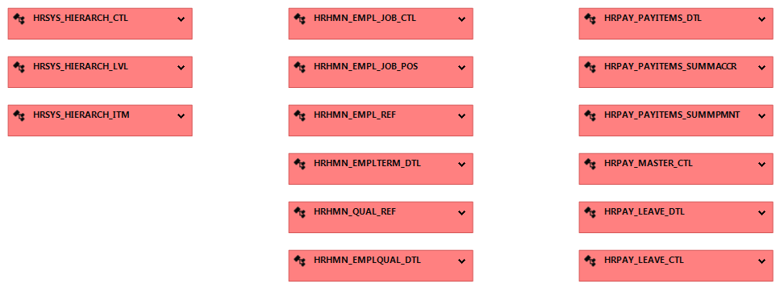
Figure 6 T1 Conceptual Data Model

Data Warehouse Backend Model
The backend model has four areas:
- Extracted data – effectively a copy of what is in the source system
- Conforming area – data is taken from the extract area and conformed into dimension format
- Management area – data structures for managing ETL processes
- Delivery area – this is mostly ETL, but any structures used for aiding delivery of the data to the frontend will go here.
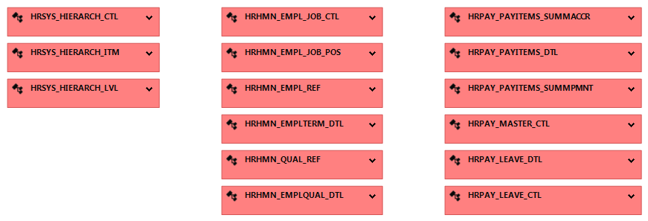
Figure 7 DWH Backend Extract Data Model
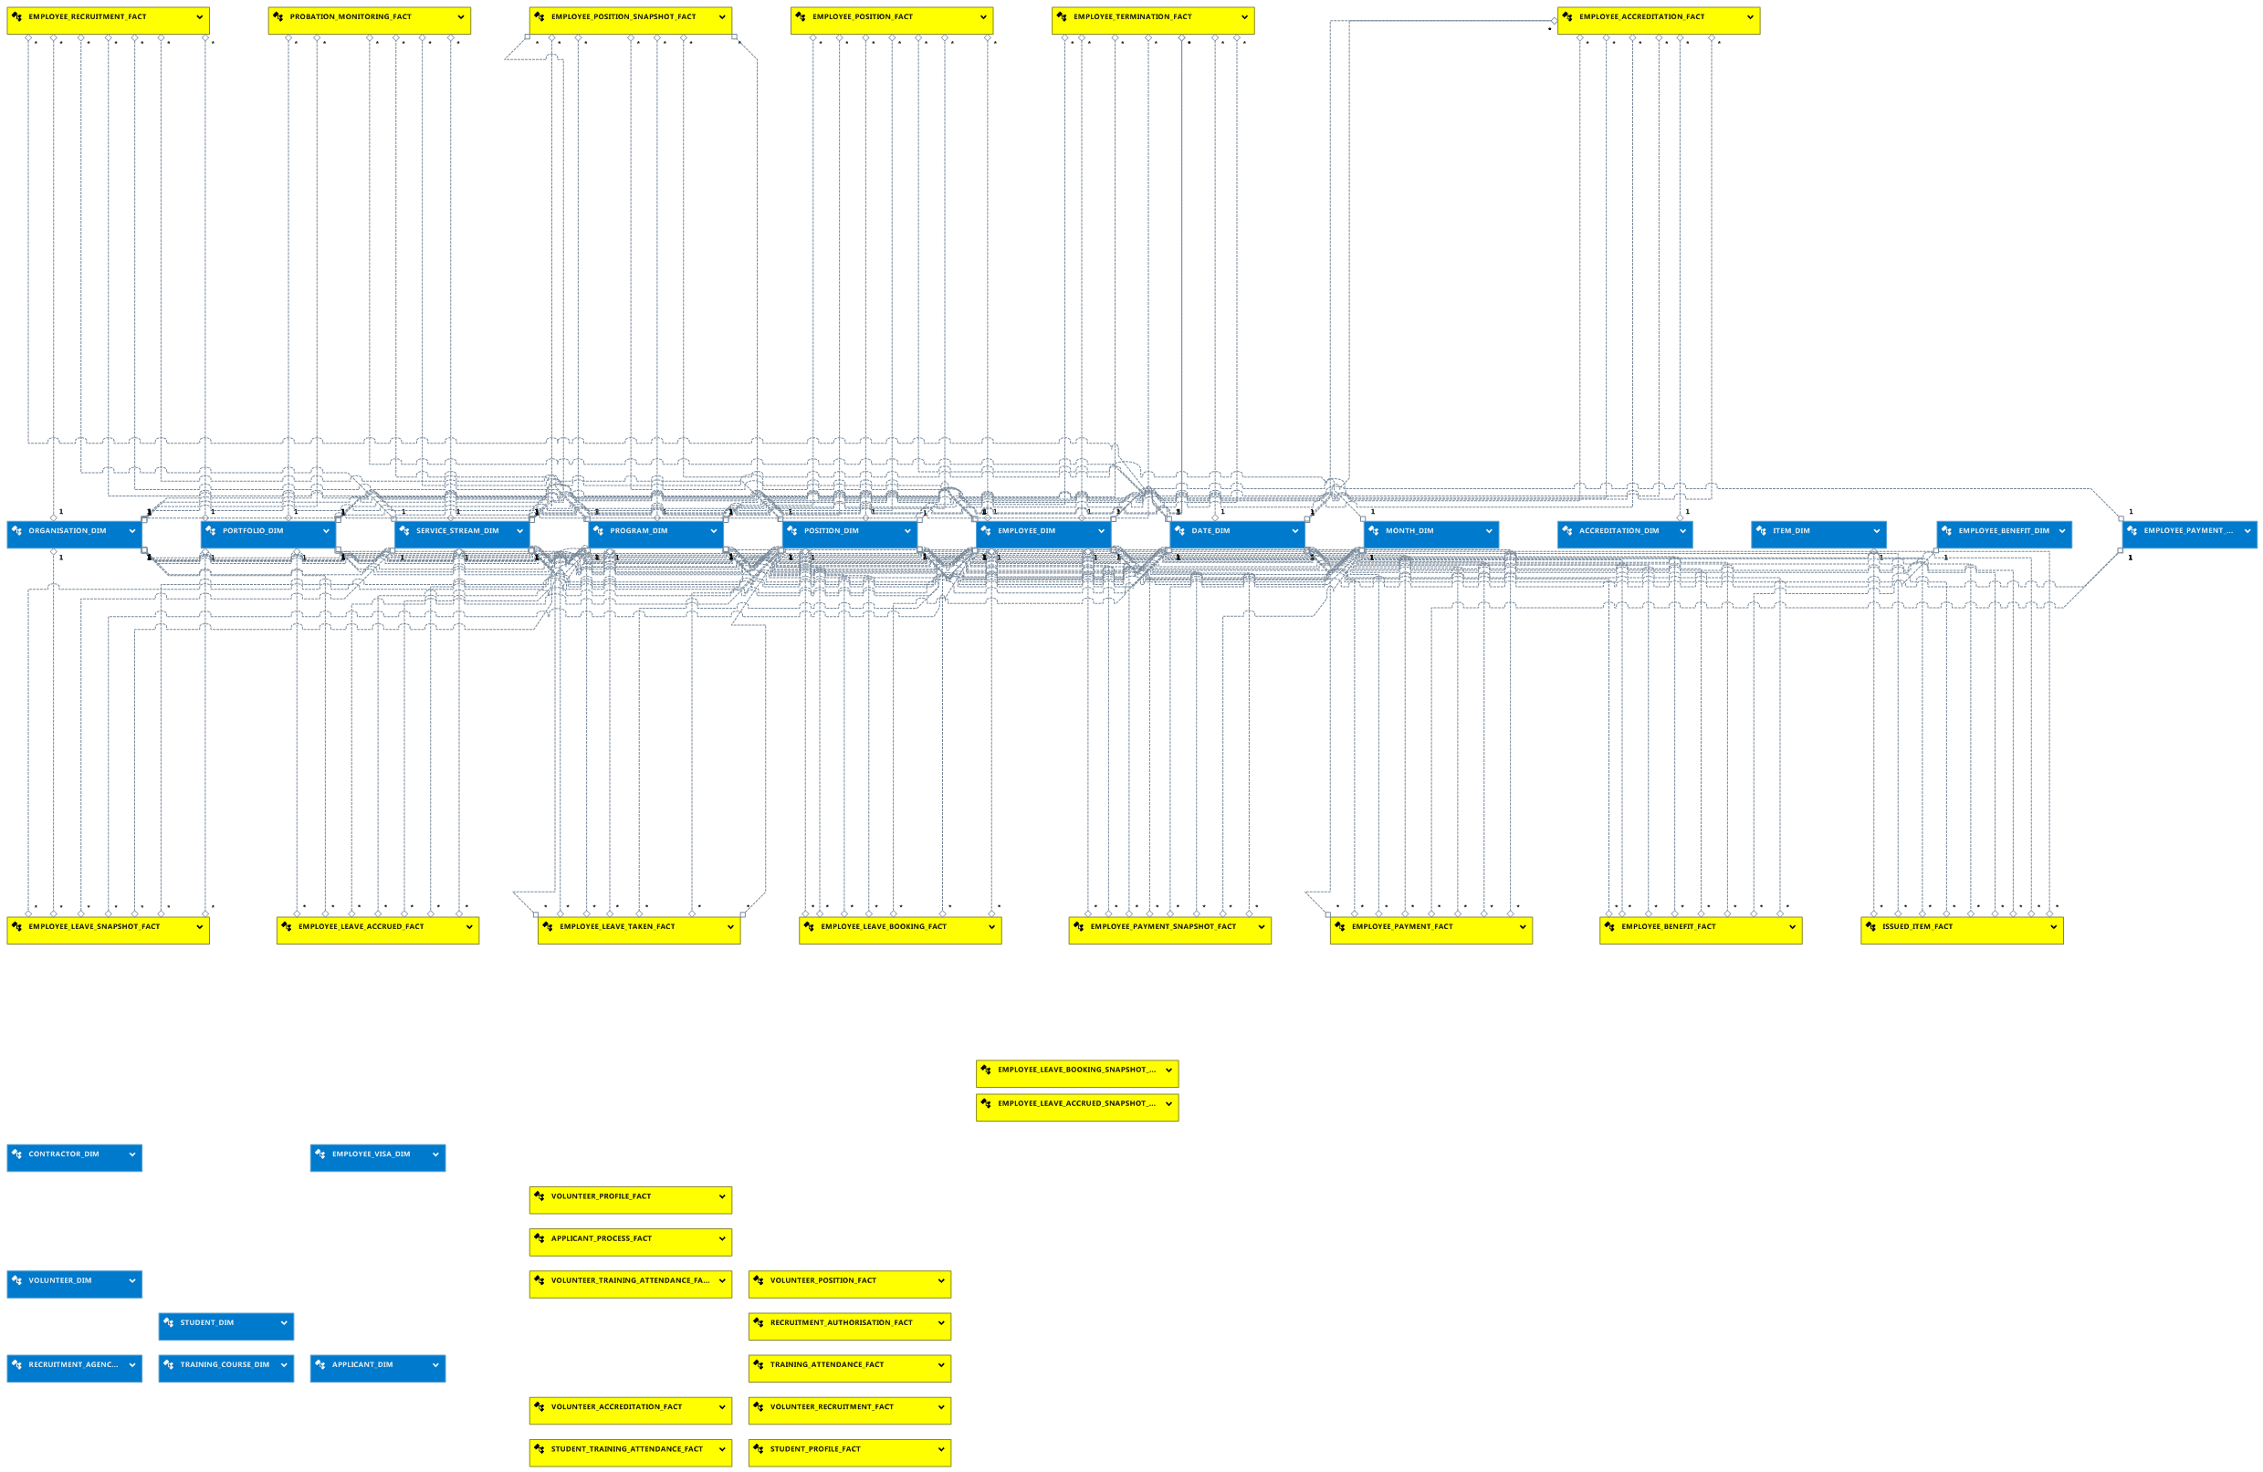
Figure 8 DWH Backend Conform Data Model

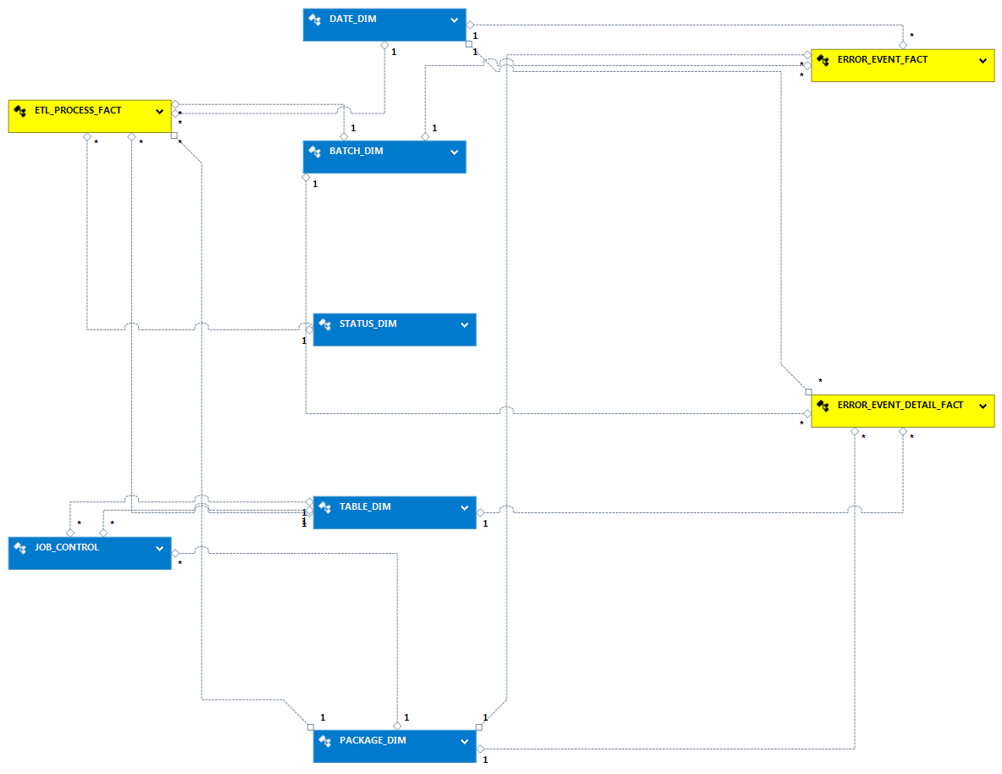
Figure 9 DWH Backend Management Data Model

Data Warehouse Frontend Model
The frontend model is very similar to the backend conform model. The reason for this is that it makes the deployment sub-system very straightforward as it is effectively just copying data from the front to the backend.
The frontend warehouse is a fully historical dimensional database, meaning that it tracks business events over time so that analysis can be drawn from it.

Figure 10 Data warehouse conceptual data model

Data Volume
Based on data in the UAT system, the predicted size of the warehouse will be approximately 20 GB at the end of year one in the production environment. Calculations are given in Annex A.

Backup and Retention
Key features of the backup strategy:
- Daily backups of both backend and frontend warehouses (based on ETL jobs running daily).
- Retention of backup files will be two months (TBC).
- Backup files will be stored in the cloud, but separate to the actual warehouse.
- Backups will be run after ETL jobs have finished refreshing the warehouse.
- Backups will be run outside of business hours.
- The backup process will be automated and scheduled.

Infrastructure View
This section is used to describe the physical/virtual hardware and networks on which the software will be deployed. The purpose of this section is to answer the following types of questions:
- Is there a clear physical architecture?
- What hardware (virtual or physical) does this include across all tiers?
- Does it cater for redundancy, failover and disaster recovery if applicable?
- Is it clear how the chosen hardware components have been sized and selected?
- If multiple servers and sites are used, what are the network links between them?
- Who is responsible for support and maintenance of the infrastructure?
- Are there central teams to look after common infrastructure (e.g. databases, message buses, application servers, networks, routers, switches, load balancers, reverse proxies, internet connections, etc)?
- Who owns the resources?
- Are there sufficient environments for development, testing, acceptance, pre-production, production, etc?

Production Infrastructure
Figure 11 Production infrastructure diagram
Infrastructure | Team Responsible for monitoring/management
Prod-dw01 | Comunet/Microsoft
Matrix2013 | Service Delivery team
Client PCs | Service Delivery team

Deployment View
This section is used to describe the mapping between the software (containers & components) and the infrastructure. Sometimes this will be a simple one-to-one mapping (e.g. deploy a web application to a single web server) and at other times it will be more complex (e.g. deploy a web application across a number of servers in a server farm). This section answers the following types of questions:
- How and where is the software installed and configured?
- Is it clear how the software will be deployed across the infrastructure elements described in the infrastructure architecture section? (e.g. one-to-one mapping, multiple containers per server, etc) If this is still to be decided, what are the options and have they been documented?
- Is it understood how memory and CPU will be partitioned between the processes running on a single piece of infrastructure?
- Are any containers and/or components running in an active-active, active-passive, hot-standby,cold-standby, etc formation?
- Has the deployment and rollback strategy been defined?
- What happens in the event of a software or infrastructure failure?
- Is it clear how data is replicated across sites?

Production
Figure 12 Production deployment diagram

Deployment Process
Component | Deployment Process | Rollback Process
Replicated database | - Outage in place – business users informed  - Backup performed of current database  - Execution of update scripts  - Verification testing  - Business users informed | - Database restored from last known good backup  - Business users informed
Frontend database | - Outage in place – business users informed  - Backup performed of current database  - Execution of update scripts  - Verification testing  - Business users informed | - Database restored from last known good backup  - Business users informed
Backend database | - Outage in place – business users informed  - Backup performed of current database  - Execution of update scripts  - Verification testing  - Business users informed | - Database restored from last known good backup  - Business users informed
Reporting Services | - Outage in place – business users informed  - Backup performed  - New install/patches applied  - Verification testing  - Business users informed | - Restore from backup  - Business users informed
ETL | - Outage in place – business users informed  - Backup performed  - New install/patches applied  - Verification testing  - Business users informed | - Restore from backup  - Business users informed
Payroll Area | - Space is created | - Space is recreated
HR Area | - Space is created | - Space is recreated
BI Interface | - Standard Install run on client desktop PC | - Reinstall/repair install

Operational & Support View
Most systems will be subject to support and operational requirements, particularly around how they are monitored, managed and administered. This section should address the following types of questions:
- Is it clear how the software provides the ability for operation/support teams to monitor and manage the system?
- How is this achieved across all tiers of the architecture?
- How can operational staff diagnose problems?
- Where are errors and information logged? (e.g. log files, Windows Event Log, SMNP,JMX, WMI, custom diagnostics, etc)
- Do configuration changes require a restart?
- Are there any manual housekeeping tasks that need to be performed on a regular basis?
- Does old data need to be periodically archived?

Monitoring and Management
The Service Delivery team use PRTG for monitoring and management of network and services. The Reporting Warehouse will be monitored in the same way. The table below lists services that should be monitored:
Infrastructure | Component | Monitoring Aspect
Prod-dwh01
 | Memory | Excessive load (greater than 80% continuous)
 | Memory | Trends over time
 | Disk | Capacity (greater than 70%)
 | Disk | Excessive continuous IO operations
 | Disk | Trends over time
 | CPU | Excessive load (greater than 80% continuous)
 | CPU | Trends over time
 | Network | Excessive load
 | Network | Data usage over time
 | Network | Trends over time
 | Replicated database | Availability
 | Frontend database | Availability
 | Backend database | Availability
 | SSRS | Availability
 | SSIS | Availability
Matrix2013
 | Memory | Excessive load (greater than 80% continuous)
 | Memory | Trends over time
 | Disk | Capacity (greater than 70%)
 | Disk | Excessive continuous IO operations
 | Disk | Trends over time
 | CPU | Excessive load (greater than 80% continuous)
 | CPU | Trends over time
 | Network | Excessive load
 | Network | Data usage over time
 | Network | Trends over time
 | Sharepoint | Service availability

Log file locations
Infrastructure | Component | Log locations
Prod-dwh01 | Database | Need info
 | SSRS | Need info
 | SSIS | Need info
Matrix2013 | Sharepoint | Need info
Client PC | Power BI | Need info

Processes

Shutdown
Step | Instruction
1 | Take SharePoint HR and Payroll areas offline
2 | Shutdown SharePoint
3 | Ensure no ETL jobs are not running or are due to run during outage period
4 | Ensure no reports are running or are due to run during outage period
5 | Take Frontend database offline
6 | Shutdown Frontend database
7 | Take Backend database offline
8 | Shutdown Backend database

Startup
Step | Instruction
1 | Bring up Backend database
2 | Bring up Frontend database
3 | Ensure ETL system is ready
4 | Bring up SharePoint HR and Payroll areas

Take offline
Step | Instruction
1 | Take SharePoint HR and Payroll areas offline

Make online
Step | Instruction
1 | Bring up SharePoint HR and Payroll areas

Backup data
Step | Instruction
1 | Follow Anglicare-SA guidelines for backup process

Restore data
Step | Instruction
1 | Follow Anglicare-SA guidelines for restore process

Decision Log
The purpose of this section is to simply record the major decisions that have been made, including both the technology choices (e.g. products, frameworks, etc) and the overall architecture (e.g. the structure of the software, architectural style, decomposition, patterns, etc). For example:
- Why did you choose technology or framework “X” over “Y” and “Z”?
- How did you do this?
- Product evaluation or proof of concept?
- Were you forced into making a decision about “X” based upon corporate policy or enterprise architecture strategies?
- Why did you choose the selected software architecture? What other options did you consider?
- How do you know that the solution satisfies the major non-functional requirements?

ID | When | Problem | Rationale | Status
1 | 11/08/16 | Anglicare-SA have a number of reporting technologies at their disposal for creating the reporting solution, these have been documented in the HRIS Solution Outline.  Decision: Use SQL-Server, SSRS, SSIS and Power BI | The selected technologies are the only ones that satisfy all the functional and non-functional requirements within an affordable budget | Closed
2 | 11/08/16 | Decision required around where the solution will be hosted.  Options:  - In house  - Cloud based hosting  Decision: Cloud based hosting | Hosting in the cloud gives a number of advantages over in house hosting:  - Little Capex cost  - Quicker to provision  - Scalable performance  - Disaster recovery is built in  - Maintenance overheads are lower | Closed
3 | 12/08/16 | Decision required around what architecture to use for the data warehouse.  Options:  - Kimball  - Inmon  - Data Vault – Dan Lindstedt  Decision: Kimball | Kimball is by far the most popular choice for data warehouse solutions and is widely accepted across a variety of industries. Experience within Anglicare-SA is limited to Kimball and Data Vault, with a preference for Kimball. | Closed
4 | 22/8/16 | Decision needed around source control for the development project.  Options:  - VisualStudio team services (GIT based)  - GitHub  Decision: GitHub | Configuring VisualStudio team services proved difficult in the time available and seems to be overkill for the project needs. GitHub on the other hand just worked and was up and running very quickly. | Closed

Annex A – Warehouse Sizing

Warehouse Frontend
Dimension Sizing
Dimension | Small (< 1000 rows) | Medium (1000-100k) | Large ( > 100k)
month_dim | 1
date_dim |  | 1
portfolio_dim | 1
service_stream_dim | 1
program_dim | 1
employee_dim |  | 1
position_dim | 1
qualification_dim | 1
Table count | 6 | 2 | 0
Size per table (MB) | 1 | 500 | 10000
Size (MB) | 6 | 1000 | 0 | 1006
Fact Sizing
Source system | Size (MB) | Incremental extract percentage | Daily size (MB) | Annual size (MB)
T1 | 330 | 10.00% | 33 | 8580
Size (MB) |  |  |  | 9586
Warehouse Backend
Description | Size (MB)
Replicated T1 data |  |  |  | 35
Staged T1 data |  |  |  | 4793
Working T1 data |  |  |  | 4793
Control tables |  |  |  | 10
Size (MB) |  |  |  | 9631

